**PRACTICAL NO 4**

**AIM:** Practical of Hypothesis testing.

**A.**Hypothesis testing of a Single Population means.

**Step 1:** First we have to create Excel file and Enter the 28 values so that we can fine deviation, Square of deviation, population, differentiate of mean, T-value, and system calculate standard deviation and save as **.**CSV file.

#### Output:

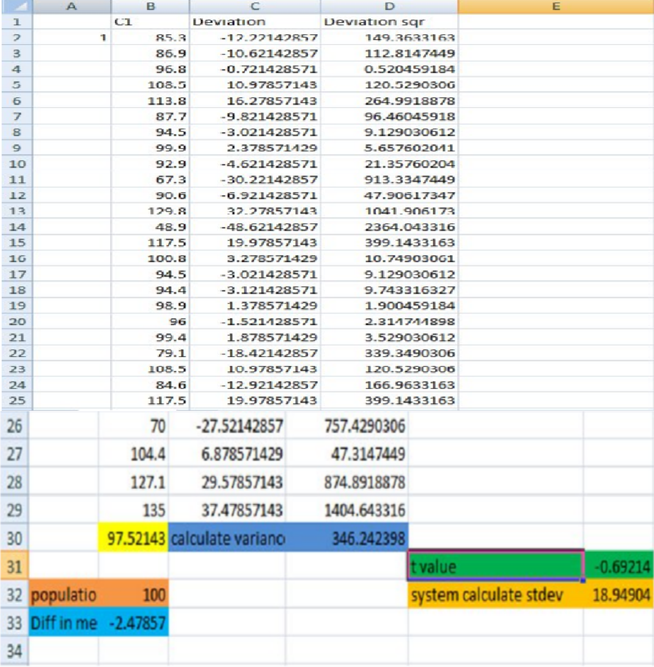

**Step 2:**Now we have to import Excel file (onetest.csv) type bellow command. #datanew=read.csv("D:/onettest.csv")

#datanew

#### Output:

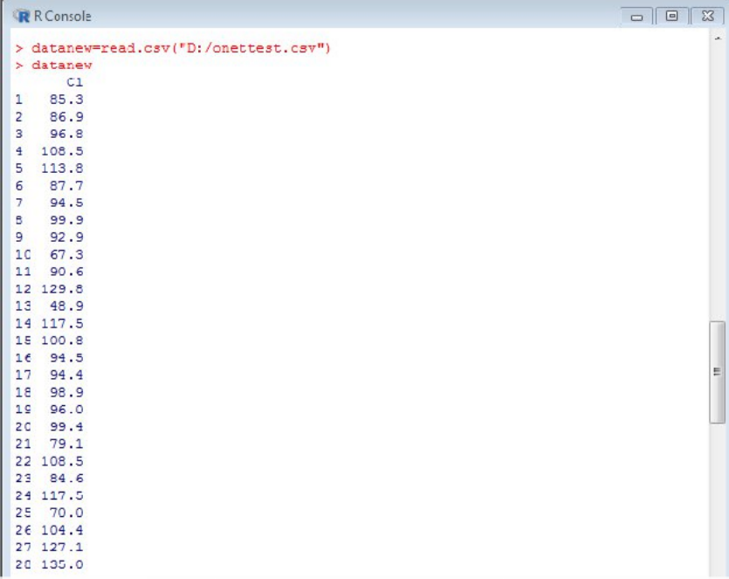

**Step 3:** After importing onetest.csv file we will plot Boxplot diagram type bellow command. #boxplot(datanew)

#### Output:

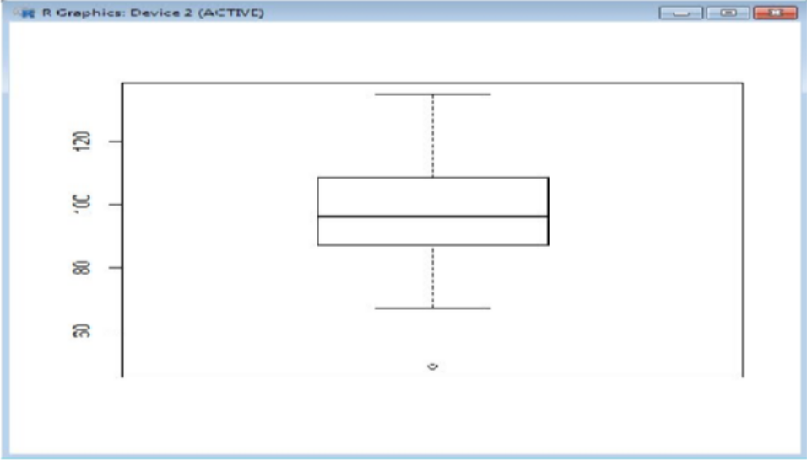

**Step 4:**After that find mean of respective data. # m1=mean(datanew$C1)

#m1

#### Output:

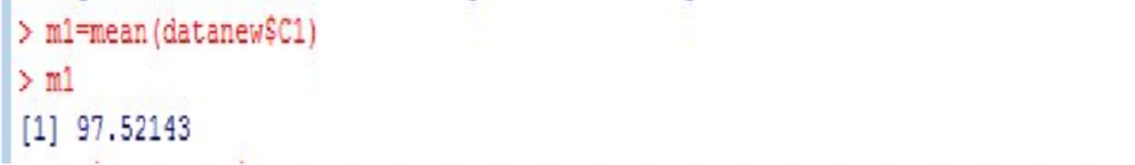

**Step 5:**Now calculate the standard deviation. #sd1=sd(datanew$C1)

#sd1

#### Output:

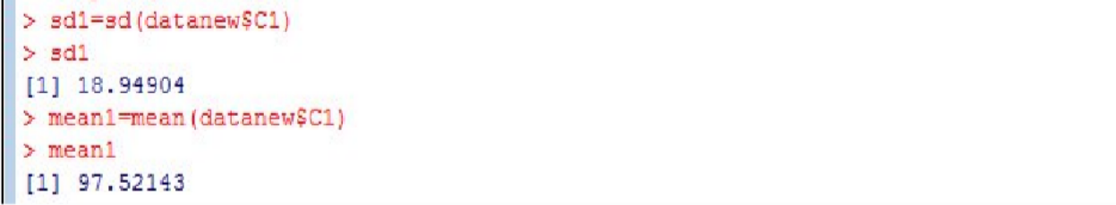

**Step 6:**Plot bell curve. # plot(datanew$C1)

#### Output:

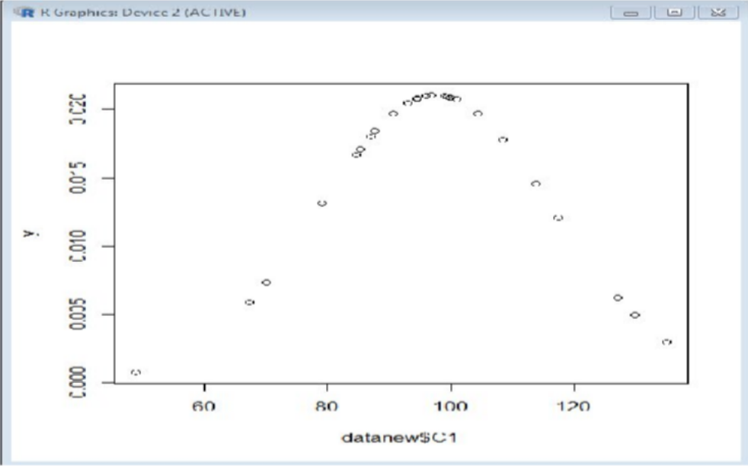

**Step 7:** At the end find T-Test value type following command. #t.test(datanew$C1,alternative="greater",mu=100)

### Output:

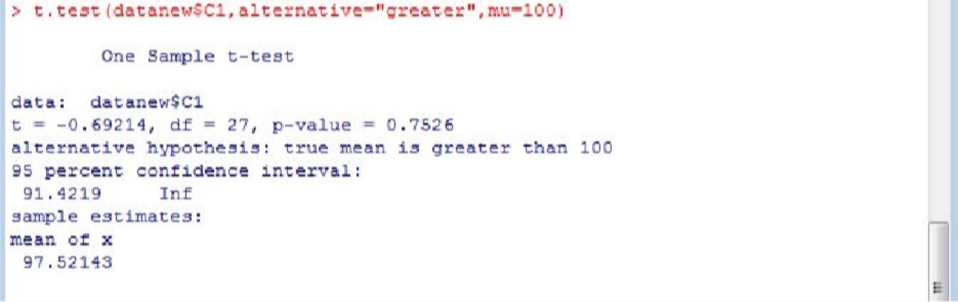

**CONCLUSION:**Thus we have implementedHypothesis testing of a Single Population means successfully.